LEVEL 1 FLOOR (1)
Statics | 1. ® © Fwd roll to squat, jump feet back to front support, turn over to rear support, sit and reach fwd to pike stretch (hold 2 sec) momentary dish, candlestick to stand |  | - Feet together  - Straight leg push then tuck to squat  - Top of Head should not touch the floor  - Front support – straight arms, hips open, chest in  - Rear Support – Straight arms, hips open  - Sit and touch toes – Legs straight  - Dish – chest in, legs straight, shoulders and legs lifted off ground
Fwd Roll  (for front salto) | 1. Rock n rolls to stand | 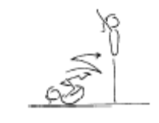 | - knees together, toes pointed  - ability to generate a smooth rocking action alone  - hands on the front of the shins, below the kneecaps  - head tucked in, with chin on chest
Handstand (for walkover, handspring and flic flac) | 1. Angry Cat/Happy Cat position – hold 30 secs
 | 2. Angry cat on floor, turn toes under and straighten legs – keep chest in – back rounded – hold 30 secs
 | 3. Angry cat on a box – hold 30 secs
 | 4. Angry cat on a box, turn toes under and straighten legs – keep chest in – back rounded – hold 30 secs
 | 5. As above – coach lifts one leg towards handstand – as soon as good form is lost – lower and repeat
 | 6. Lying on stomach with hands against a wall – looking at hands, covering ears – chest in, bottom squeezed – hold 30 secs
 | 7. ® © “L” Handstand |  | - Chest in and hips open  - Feet to vertical  - Legs straight
Cartwheel / Roundoff | 1. Angry cat position – rocking from hand to hand
 | 2. F2-3.1 Side cartwheel to side handstand position, the coach checks the posture and alignment | 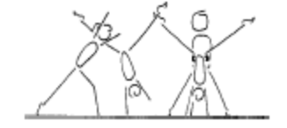 | - keep shoulders and hips square  - lunge into the side handstand  - head neutral  - maintain good body tension and alignment
 | 3. F2-3.2 Same as drill F2-3.1 – now have the gymnast rock back and forth
 | 4. F1-4.4 Cartwheel through hoops, stretch the hoops out to encourage the cartwheel to be performed in a straight line | 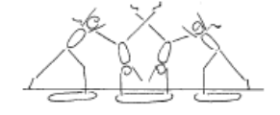 | - maintain good body tension and alignment  - pass through a plie into and out of the skill  - hands parallel, straight arms  - head neutral  - small straddle  - keep arms by ears all through the skill
 | 5. © Cartwheel from a raised surface (bench or box) to the ground (hands on the raised surface) |  | - Reach forward, straight body tilt  - Chest in, turning at last second  - Even rhythm throughout  - Open hips  - Straight direction  - Straight legs
 | 6. F1-4.5 Side cartwheel along a wall (can be done with back or stomach facing the wall) | 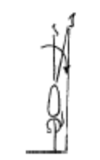 | - maintain good body tension and alignment  - pass through a plie into and out of the skill  - hands parallel, straight arms  - keep body in line bar the mat  - head neutral  - small straddle  - keep arms by ears all through the skill
 | 7. F2-3.3 Perform cartwheel between 2 supersoft mats
 | 8. ®* Cartwheel to side
 | 9. Corbettes from beat board

LEVEL 1 FLOOR (2)
Backward Roll (for back salto) | 1. F2-4.1 Have the gymnast lie on their back on a supersoft mat, their head is just off the edge, the gymnast places their hands on the floor and performs a backward roll. Once this is mastered they can start from a tuck sit on the supersoft mat | 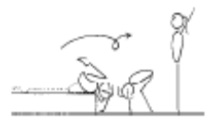 | - confidence and understanding  - legs together  - land on feet and stand  - use hands effectively
 | 2. F2-4.2 Backward roll in a channel, the gymnast performs the backward roll between 2 supersoft mats, or low shapes | 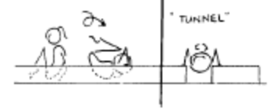 | - confidence and understanding  - legs together  - land on feet and stand  - use hands effectively
Stride Leaps | 1. ® © 2 x fwd kicks to horizontal | 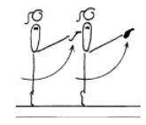 | - Supporting leg straight  - Good posture  - Free leg straight and min. horizontal
 | 2. Step kick & hop – hold leg up – land with bent supporting leg and hold
 | 3. Landing position jumps along beam – back leg held
 | 4. F2-2.2 Have gymnasts “leap” over higher (approx knee height) obstacles | 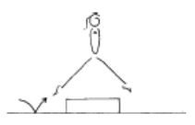 | - emphasise rhythm and form  - chin up, eyes down  - arms symmetrical  - emphasise lifting the back leg  - hips and shoulders square
 | 5. F2-2.3 In groups of three, have the gymnast perform a stride leap | 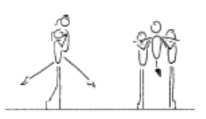 | - this drill gives the gymnast some extra time in the air  - emphasise rhythm and form  - chin up, eyes down  - hips and shoulders square  - lift the back leg
 | 6. F2-2.5 stride/split jumps on the trampoline (double mini)
Leaps/Jumps | 1. ® © 2 x step hops in attitude |  | - Supporting leg straight  - Good posture
 | 2. ® © Step feet together, straight jump |  | - Stretched position  - Good height  - Legs together  - Torso vertical, hips tucked under  - Legs and feet fully extended throughout
Body Wave | 1. F3-1.1 From lying on the floor have the gymnast spread their arms to the side and arch their upper body.
Turns | 1. Side passé, fwd passé releve & turn holding onto something stable – for beginning and end of turn
 | 2. Straight jump rebound straight jump
FWO, BWO & Tic Toc | 1. F2-5.4 Bridge with feet raised on a box
 | 2. From stand close to wall – push hips fwd and look back to touch wall behind – keep arms close to head | 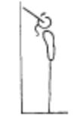 | - keep hips in line with feet  - stretch up first then open shoulders to initiate the back arch  - keep gluteal muscles tight  - maintain good body tension and alignment
Hurdle | 1. F4-2.1 Stand in dish shape leaning fwd against a wall

LEVEL 1 BARS (1)
Tuck Swings /Glides | 1. B1-3.4 Jump from the floor catch the bar and land on the board in the correct position | 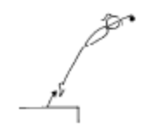 | - show a rounded body position on the jump to catch the bar  - head neutral, chest rounded and hips under
 | 2. ® © 2 x tuck swings | 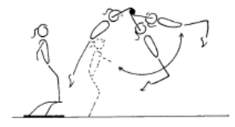 | - show a rounded body position on the box/board, head neutral, chest rounded and hips under  - straight arms throughout the swing  - can have a slight knee bend if necessary  - chest rounded and hips under throughout the swing  - relaxed shoulders  - the swing should gain amplitude  - a slight ‘tap’ action should be evident  - a safe controlled landing on the floor, at the back of the swing
 | 3. Using box hold front of glide
 | 4. Glide on roller
 | 5. B2-2.2 Glide swing spotted – coach swing gymnast holding the gymnasts feet
 | 6. B3-5.1 Perform glide swing and kick the cube/ball out the front | 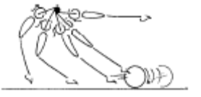 | - maintain good body tension and alignment
Front Support /Casts | 1. Hold front support on floor | 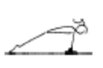 | - straight arms throughout the jump to front support  - chest rounded
 | 2. Hold front support on box
 | 3. ® © Jump to front support with straight arms, from feet under bar, (bar at chest height or above in starting position) | 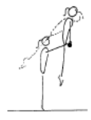 | - Arms straight throughout  - Chest in and hips open
 | 4. Shrugs | 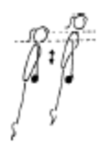 | - straight arms throughout the jump to front support  - chest rounded
 | 5. Holding ‘lean fwd’ position on the bar in front support
 | 6. B2-3.5 Support swings on parallel bars | 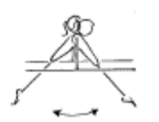 | - arms must stay straight  - head neutral  - fast backward body snap action  - dish shape at the front and back ascent peak phase
 | 7. Spotted casts | 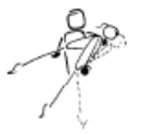 | - arms must stay straight  - head neutral  - fast backward body snap action  - dish shape at the ascent peak phase
 | 8. ® © 2 x Casts – hips clearly off the bar |  | - Strong pike to strong heel lift  - Straight body  - Chest in  - Hips open at top of cast
Fwd Roll Dismount | 1. Hold tuck position hanging on bars – 5 secs
 | 2. Show pike position with toes to the bar
 | 3. Inverted hang and slide down to holding toes to the bar – 3 secs then tuck – 3 secs
 | 4. ® © Fwd roll to tuck hang, hold for 3 sec | 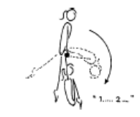 | - Shoulders open, chest in  - Head neutral  - Knees to chest  - Momentary hold

LEVEL 1 BARS (2)
Pullover | 1. B2-1.1 Tuck leg lifts on wedge x 5 | 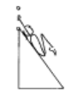 | - bring knees to chest  - maintain good body tension and alignment
 | 2. B2-1.2 Hold a bar (or rope) in hands, rotate backwards to touch feet on or near the floor | 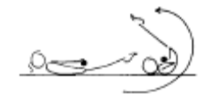 | - keep bar near hips  - legs together  - initiate rotation
3. Chin up hold

10 sec
 | 4. © B2-1.3 Perform an assisted pullover using a ‘wedge’ shape tied to the bar | 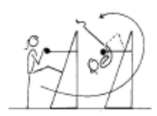 | - bring chin to the bar, simultaneously kick legs up to the vertical line and then around the bar  - join feet early  - fast rotation  - move wrists quickly  - finish in good front support
 | 5. B2-1.4 Coach assisted pullover | 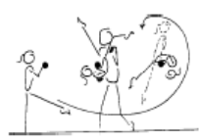 | - bring chin to the bar, simultaneously kick legs up to the vertical line and then around the bar  - join feet early  - fast rotation  - move wrists quickly  - finish in good front support
Back Hip circle | 1. B3-1.2 Hold a dish support and an inverted dish hang (may need coach assistance | 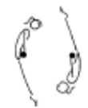 | - head neutral  - maintain good body tension and alignment
Toe Shoot Dismount | 1. B3-2.1 – Hang on low bar in straddle position | 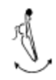 | - ensure good closure  - balls of the toes on the bar
 | 2. B3-2.3 On a floor bar, step feet into straddle on the bar, fall to land on a supersoft mat | 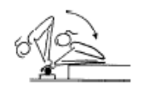 | - bring feet down under onto the bar, not around the side  - ensure good closure  - balls of the toes on the bar  - head neutral
Cast to Squat | 1. B4-2.1 Stoop, straddle and squat on a line on the floor | 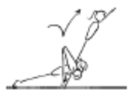 | - shoulders forward  - arms straight  - lifts hips high and place feet in line with hands  - quickly lift shoulders and jump off
Long Swings & Long Swing Pullover | 1. B1-4.1 Perform dish and arch shape on floor | 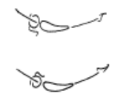 | - maintain good body tension and alignment
 | 2. B1-4 Hang in arch, dish and straight for 5 seconds each | 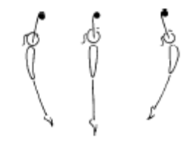 | - Hang in an arch position for 5 seconds (key position for the ‘tap’ later on)  - maintain good body tension and alignment  - maintain a rounded ‘bow’ shape  - relaxed shoulders  - open hips (feet back)  - Hang in a dish position for 5 seconds  - maintain good body tension and alignment  - maintain a rounded ‘dish’ shape  - relaxed shoulders  - Hang in a straight position for 5 seconds  - maintain good body tension and alignment  - maintain a straight shape  - hips open
 | 3. B2-4.1 Coach places one hand in front of gymnast’s feet and one hand behind gymnasts feet, from a straight hang on the bar the gymnast tries to hit both targets with feet | 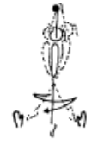 | - head neutral  - maintain good body tension and alignment  - a strong rhythm must be visible  - gymnast must feet a good rhythm
Kips | 1. Kip drill on ladder – with straight arms (turn head to side)

LEVEL 1 BEAM (1)
Front support Mount | 1. M1-1.3 Stride sit/support on the beam, swing legs | 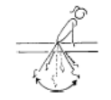 | - maintain good body tension and alignment  - arms straight  - shoulders will be slightly in front on hands during the back swing  - keep torso clear of the Beam
 | 2. ® © Jump to front support, lift leg over to straddle sit, swing legs behind to squat and stand | 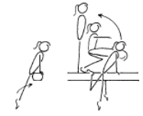 | - straight arms in front support  - legs straight during the first phase  - during the swing to squat, or lift feet behind, keep arms straight and head neutral  - in the squat have shoulders upright and weight on the balls of the feet
Kneeling Scale | 1. Practice kneeling scale position on bench/low beam | 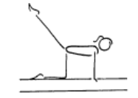 | - arms straight throughout skill  - back leg straight  - head up, eyes down  - square position with arms torso and thigh of support leg  - stable balance
Squat on Mount | 1. Diagonal Squat on to a low bench and low box
Arabesque /Posture | 1. M1-2.3 Fingers should be graceful – have the gymnast hold their arms to the side with a pencil placed between the fingers to gain the “correct” feeling – thumbs tucked away | 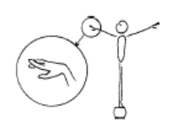 | - fingers stretched, and relaxed, thumbs should be under the hand, middle finger down and pointer finger up.
 | 2. M2-2.1 Have the gymnast stand 1-2 steps out from the wall, then have them raise their arms to high oblique, their challenge is to touch their fingers on the wall
Attitude Steps | 1. ® © 2 x attitude steps – right and left | 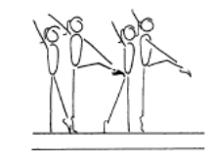 | - one arm moves to low oblique to touch the top of the opposite knee, the other arm repeats the same pattern  - support leg is straight  - the free leg is turned out and the knee is lifted to hip height  - steps are to be performed on toes  - hips under, stomach pulled in  - head up, eyes down  - good rhythm  - stable balance
Releve/Turns | 1. M1-2.1 Releve on the beam – held for 10 sec x 3 | 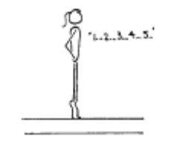 | - hips under, stomach pulled in tight, squeezed gluteal muscles  - shoulders down  - locked knees and tight legs  - heels pushed forward into a high arch shape  - one foot slightly in front of the other  - hands on hips
 | 2. ® © ½ turn on 2 feet | 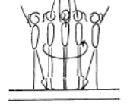 | - legs straight  - turn to be performed on toes  - hips under, stomach pulled in  - head up, eyes down  - spot the end of the Beam prior to turning , then spot the other end of the Beam on the completion of the turn  - good rhythm  - stable balance  - turn whole body as one unit
 | 3. M1-7.2 Side Passe, Fwd Passe, Releve on 1 foot for 2 secs
 | 4. ® © Right/Left pivot walks (Forward passé) point step |  | - Straight legs  - Straight posture  - Head up  - Good rhythm  - Toe to knee in fwd passé
 | 5. ®* Right/Left pivot walks (side passé to fwd passé – develope, point, step weight transfer

LEVEL 1 BEAM (2)
Locomotion | 1. ® © 4 x steps fwds (point step weight transfer) | 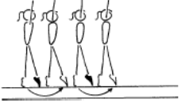 | - Straight legs  - Straight posture  - Head up  - Good rhythm
 | 2. ®* 4 x steps in releve (on toes)
 | 3. M1-5.1 Stand on the floor with free leg on low beam in attitude position, swap legs | 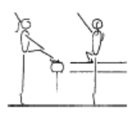 | - emphasise the turn out and toe point  - head up, eyes down  - good posture  - opposite arm to leg
 | 4. M2-3 Skipping along bench/low beam | 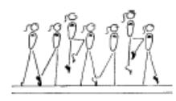 | - good rhythm  - confidence  - good body alignment and control  - extended toes, ankles, knees and hips
Jumps /Leaps | 1. © M1-10.1 Have gymnast stand on the beam, arms swing fwd and upward as gymnast moves into a releve hold for 5 secs, then lower into a small plie arms swing downward to land in front and present | 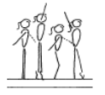 | - ensure efficient use of arms  - ensure shoulders upright at all times  - knee bend should not exceed 45’  - heels pushed forward into a high arch position  - hips under and stomach pulled in  - head up and eyes down  - emphasise square hips and shoulders during take off and landing
 | 2. ®* Straight Jump | 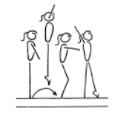 | - square hips and shoulders throughout the skill  - vertical take off  - extended toes, ankles, knees and hips in flight  - both heels on to the Beam on landing  - body vertical during landing
 | 3. M1-10.3 On low beam or bench - perform various positional jumps including tuck, star, ¼, ½ | 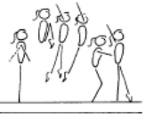 | - maintain good body tension and alignment  - emphasise square hips and shoulders during take off and landing
Stride Leap | 1. Step kick & hop – hold leg up – land with bent supporting leg and hold
 | 2. Landing position jumps along beam – back leg held
 | 3. M3-2.3 Leap progression R/L off the end of the low beam onto stack mats | 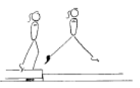 | - arms side horizontal  - square hips and shoulders  - keep body upright
Body Wave | 1. M2-4.1 Start on knees, have the gymnast move from straight to arch to contraction - repeat | 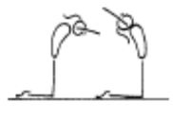 | - the shape (arch or contraction) is from the base of the spine to the top of the head  - maintain good body tension and alignment
Handstand | 1. © M3-4.1 Front support with hands on a middle beam and feet on a higher box – performed to the front | 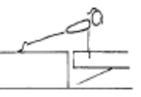 | - shoulders and hips square  - hips under, chest in  - head neutral
 | 2. As above – then raise 1 leg towards vertical
Landing Drills | 1. Can you move me/ shake me in landing position
 | 2. Clap – don’t jump off beam until coach claps
Straight Jump Dismount | 1. ® © ¼ turn – straight jump dismount | 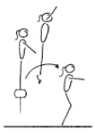 | - stretched arms overhead  - legs straight in the air  - vertical take off  - on landing the hips must be under  - on landing the shoulders, hips and ankles should all be in a vertical line
Punch Set D/Mt | 1. M4-2.1 Bounces along beam | 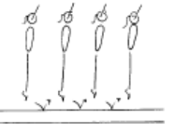 | - bounce through the toes, ankles and knees  - minimum bend of legs  - fast explosive movement  - good rhythm

LEVEL 1 VAULT (1)
Landing | 1. Jump from a box to safe landing position (SLP) on floor
Bounce /Spring | 1. Ankle raises x 20 with both feet then 15 on each leg
 | 2. V1-1.1 Assisted bounces on the floor – coach holds the gymnast by the hands in front
 | 3. V1-5 Springing Circuit – variety of 8 objects | 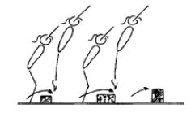 | - maintain good body tension and alignment  - continuous bouncing, no pauses or stops  - easy clearance of the objects
 | 4. V1-4 10 skips with a skipping rope
Running | 1. V2-3.1 Stand swing arms bent 90’ | 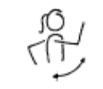 | - bent arms - arms do not drop, or straighten out  - alignment - arms do not swing across body or out to the side  - arms have 90’ bend, lift to eye level and swing back to body line
 | 2. fast run over beat board- consistent speed and stride
 | 3. V2-3.2 From stand – march lifting knees and using arms | 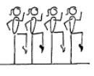 | - lift knees  - toes pointed  - arms have a 90’ bend, lift to eye level and swing back to body line
 | 4. Running drill – arm swing – using 1 knee lift while swinging both arms
 | 5. Running drill – holding foam – knees hitting foam
Hurdles | 1. Step hurdle to spring on floor – arms down when feet land
 | 2. V1-3.1 Perform hurdle from the edge of a low box – to the floor (with a fast rebound) – learning arm action
Straight Jump Vault | 1. ® © Short run, hurdle with arm circle, 2 feet take off, straight jump from spring board to 30cm crashmat or box | 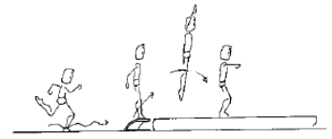 | RUN  - Tall body, slight lean forwards  - Chest in  - Quick cadence, fast reaction off floor  - Body moves forward smoothly  FIRST FLIGHT  - Hurdle is flat, not high  - Arms circle, or swing backwards then strong and fast forward & up  - Feet together fast at top of the board  REPULSION  - Arms drive through as feet impact  - At rebound feet, hips & shoulders are aligned straight  - Arms reach vertical as body leaves the board  SECOND FLIGHT  - Body stretched, hips open, arm lift  LANDING  - Chest in  - Strong landing position
 | 2. ®* Short run, hurdle with arm circle, 2 feet take off, straight jump from spring board to 60cm crashmat or box
Handstand Flatback | 1. V2-1.1 Shoulder shrugs in front support – holding form | 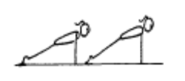 | - head neutral  - maintain good body tension and alignment
Catsprings -Handspring Vault | 1. V2-2.3 Wheelbarrow walking – hold gymnast above the knee | 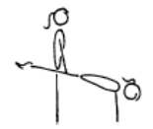 | - rounded back  - hips under & arms straight  - head neutral
 | 2. Clap push up with hands on a box
 | 3. V2-2.2 Bounce in front support on double mini | 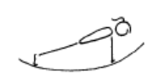 | - arms straight  - straight body  - maintain good body tension and alignment
 | 4. Straddle on 2’ box, jump off to SLP
Dive Roll / Front Salto | 1. From a run, straight jump onto 60cm mat with straight legs and chest snap
 | 2. V3-2.2 From stand dive roll up onto a supersoft mat

